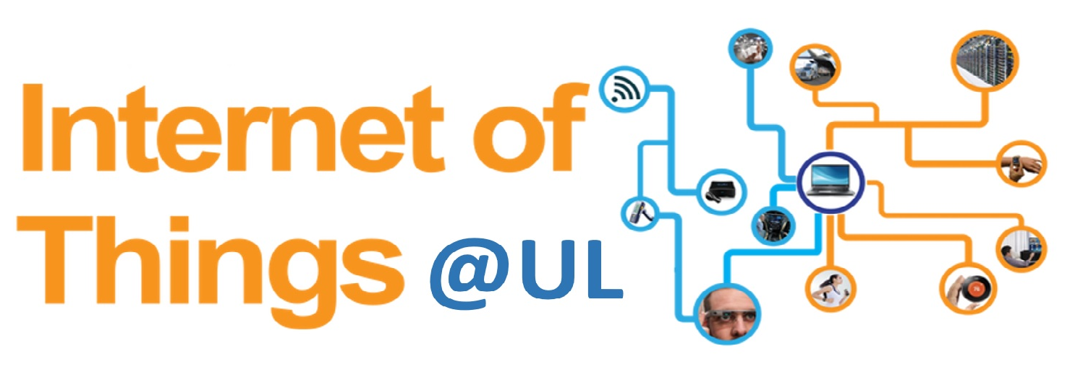

IoT Summer School



OpenWhisk

Serverless Computing Lab

Table of Contents

1 OpenWhisk
IBM recently launched a service called OpenWhisk; a distributed compute service to execute application logic in response to events. The most notable advantages of such serverless framework is:
- Auto-Scaling: automatically instantiate multiple instances to fulfill concurrent requests.
- Pay-Per-Use: pay only for the compute time you use, in millisecond increments!
OpenWhisk supports Node.JS, Python, Swift, and Docker. However, it does not natively support Node-Red, a graphical editor for “wiring” the Internet of Things.
Being Node-Red one of my favorite tools, I have been thinking about ways to use the Node-Red graphical editor and still benefiting from OpenWhisk’s auto-scaling. Here’s what I want to achieve:

2 Background Knowledge

3 Prerequisites
It is assumed you have completed the IoT Summer School Node-RED lab.
Download and install the OpenWhisk CLI. Follow the link provided below.
https://console.bluemix.net/openwhisk/learn/cli
It is still possible to complete this lab without the OpenWhisk CLI. However you will need to email the teaching assistant the command that you see on the web page.
Warning: This command has arguments that are unique to your own organization and space, so it will be different for each student.
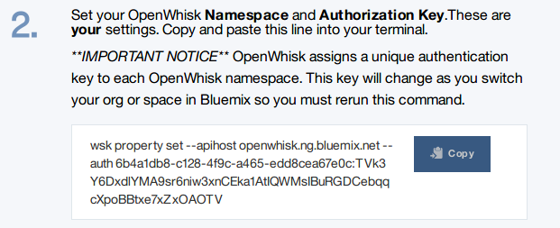

After receiving the email, the teaching assistant will use this command on their Ubuntu machine that has the OpenWhisk CLI installed. The command will generate the authorization code needed for your Node-RED flow to interact with your own OpenWhisk actions. Alternatively ask another student in the group to do this for you if they have the CLI already installed.

3 OpenWhisk Lab

Step 1: Click on OpenWhisk
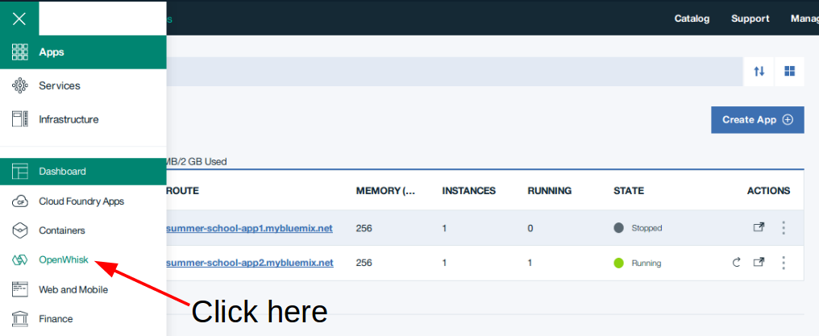

Step 2: Click on “Start Creating”
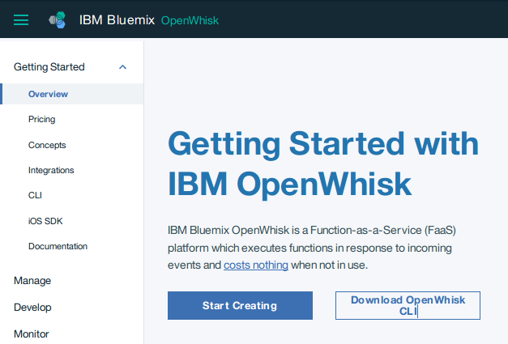

Step 3: Create Action
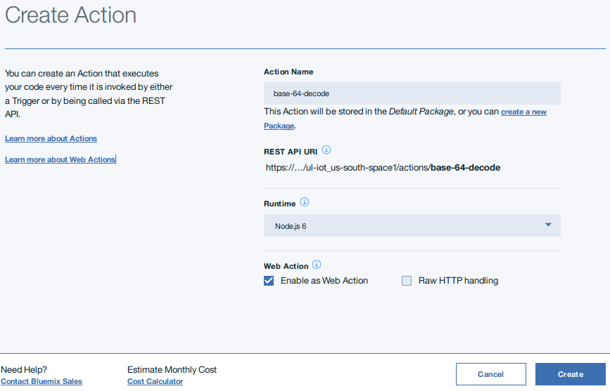

Step 4: Enter base64 Node.js code
Type and do not copy the below code
function main(params) {
var b64string = params.name;
var decodedString = Buffer.from(b64string, 'base64').toString("ascii");
return { payload: decodedString };
}
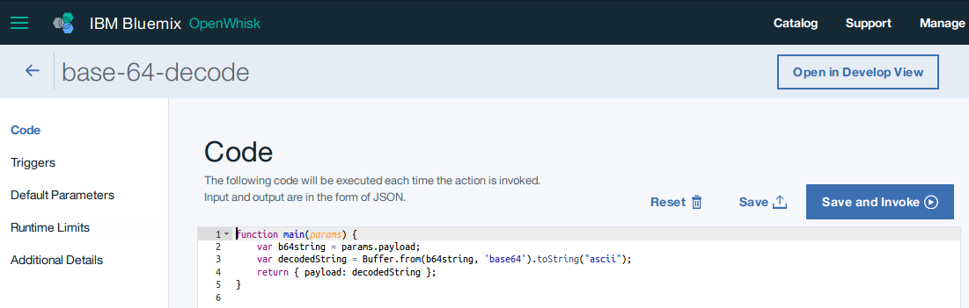

Step 5: Go back to Bluemix main page
After clicking on save in the previous step, click on Bluemix as shown in the figure below.
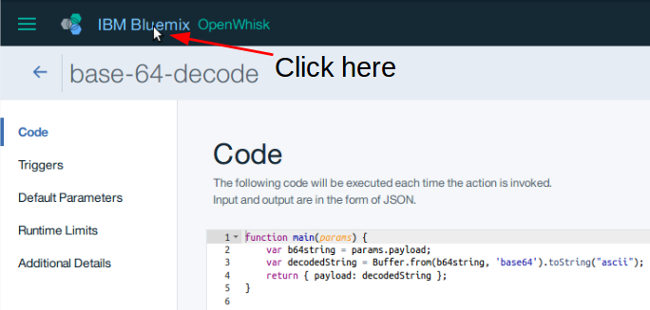

Step 6: Click on Cloud Foundry App Route
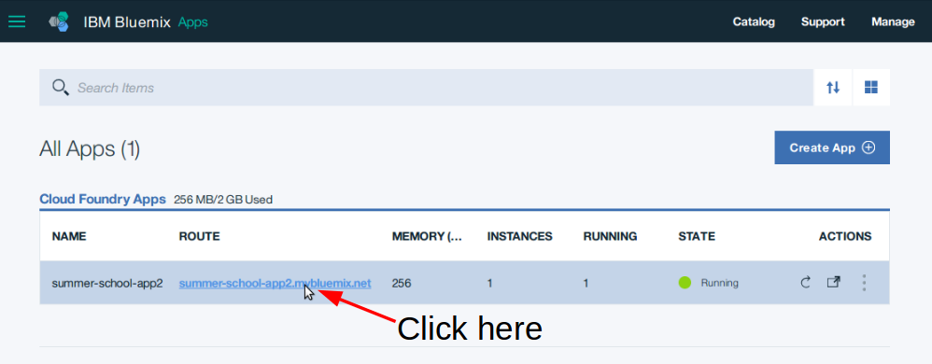

Step 7: Open Node-RED Flow editor in another tab
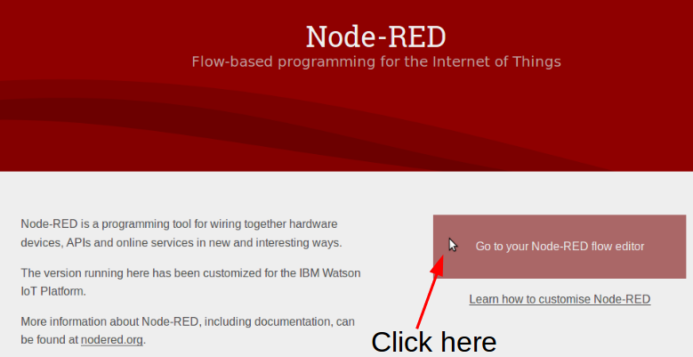

Step 8: Repeat step 1 to get back to the OpenWhisk screen
We want to be able to see our OpenWhisk Actions so we can implement changes. Do this by clicking on “manage”
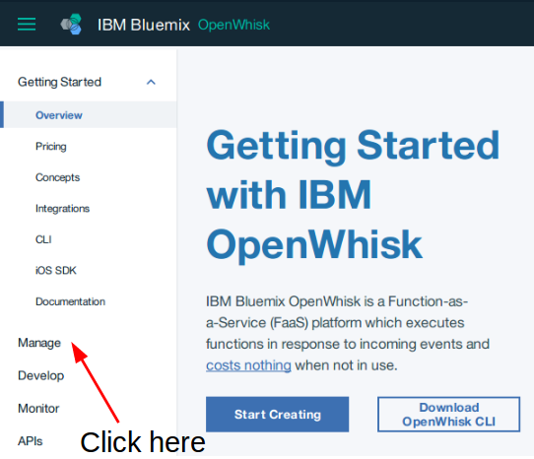

Step 9: Click on base-64-decode action
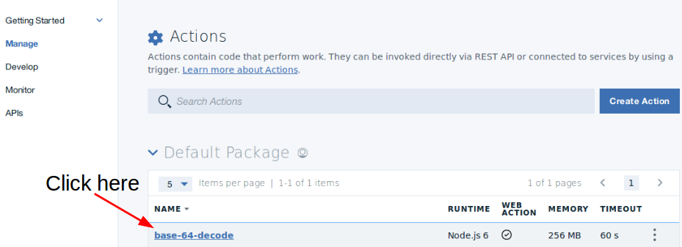

Step 10: Add a function node
Wire up the function node to the output of the mqtt subscribe node.
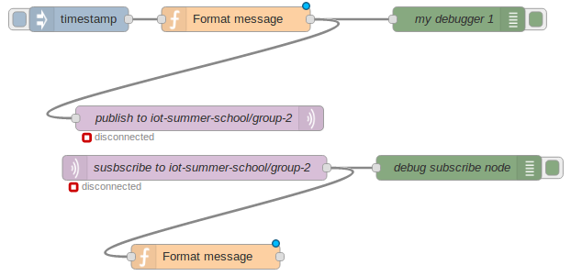

Step 11: Edit the function node
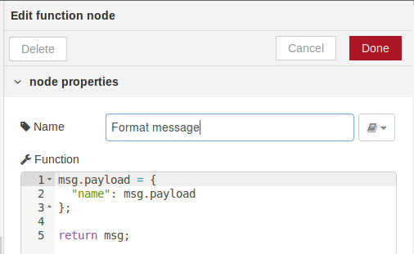
This function node changes the payload containing the base64 encoded value “hello world” into a key/value pair. This is required for the OpenWhisk action to be able to accept the arguments.

Step 12: Add OpenWhisk Action Node
The openwhisk-action node can be found under “function” node list. Drag the node onto the flow.
Connect the output of the newly added function node to the input of the openwhisk-action node.

Step 13: Edit OpenWhisk node
Click on the pencil icon to the right of the service drop-down menu.
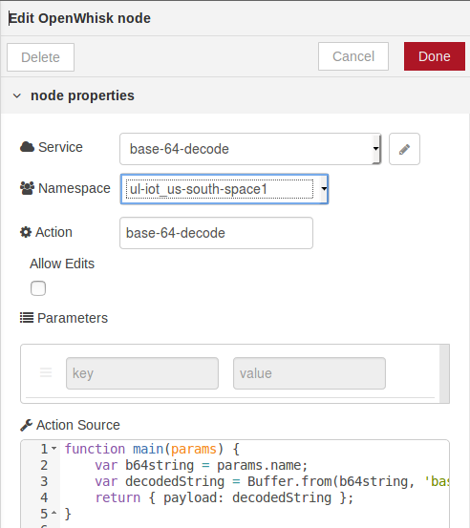

Step 14: Paste in the Auth Key obtained from the OpenWhisk CLI command
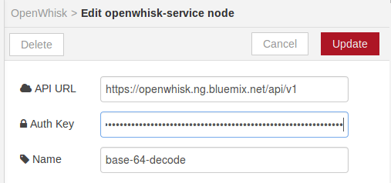
Make sure that the name field matches the name of your OpenWhisk action.

Step 15: Add debug nodes
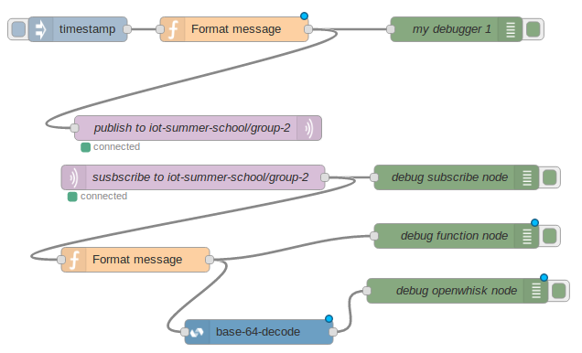
Wire up the debug nodes as shown in the figure below.

Step 16: Deploy and test
Click the inject node to test the OpenWhisk action.
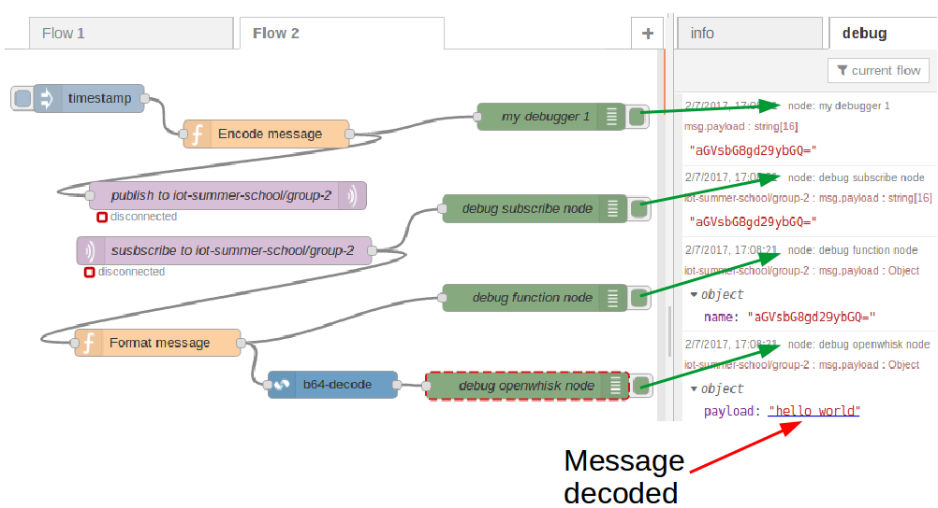

Conclusion
After completing step 16 you have successfully completed the lab.

I am not understanding the encoding/decoding part of this lab?
In the first function node “Encode message” you are encoding the message “hello world” into base64.
The result of this is “aGVsbG8gd29ybGQ=”.
This value is assigned to msg.payload and is then sent to the mqtt broker using the “mqtt out node”.
The “mqtt in node” subscribes to the topic “iot-summer-school/group<group number>”.
This is the topic the “mqtt out node” published to.
The “mqtt in node” receives a message with a payload
msg.payload = “aGVsbG8gd29ybGQ=”
This message flows into the function node “format message” where the value is formatted into JSON.
msg.payload = {
"name": msg.payload
};
return msg;
OpenWhisk accepts a single argument in JSON format. So we create a JSON key/value pair.
Where “name” is the key and “aGVsbG8gd29ybGQ=” is the value. OpenWhisk can access this value using params.name as seen in the OpenWhisk action code.
var b64string = params.name;
var decodedString = Buffer.from(b64string, 'base64').toString("ascii");
return { payload: decodedString };
The above code decodes the value “aGVsbG8gd29ybGQ=”, the result of which is “hello world”.
This value decodedString is then returned.

FAQ

I am not seeing OpenWhisk in the dropdown menu?
Check the top right hand corner to see if you are in a US-south region. If you are in the US-South region and still cannot see an option for OpenWhisk, call over the teaching assistant.

I cannot access my OpenWhisk actions using my Node-RED flow in the United Kingdom region?
You cannot use the OpenWhisk nodes but you can still however invoke your actions using REST and http nodes.

